**TITLE : DEFENDING THE DIGITAL WORLD: AI-DRIVEN CYBERSECURITY SOLUTIONS**

**ABSTRACT**

The convergence of artificial intelligence (AI) and cybersecurity has fundamentally transformed the landscape of digital defense, offering powerful tools to combat increasingly sophisticated cyber threats. As digital ecosystems grow in complexity and interconnectivity, traditional security measures are often insufficient to address emerging vulnerabilities and attack vectors. This report delves into the evolving synergy between AI and cybersecurity, presenting a comprehensive analysis of how AI technologies are reshaping the strategies and frameworks used to safeguard digital infrastructures.

Drawing insights from five authoritative research studies, this paper explores key areas such as intelligent threat detection, behavioral anomaly analysis, real-time autonomous response systems, and the integration of machine learning models in predictive and preventive defense mechanisms. It also examines the challenges associated with adversarial AI, ethical implications, data privacy, and the explainability of AI decision-making processes. Emphasis is placed on the growing importance of Human-AI collaboration, where human oversight and contextual understanding complement AI’s computational strengths to create robust, accountable, and adaptive cybersecurity solutions.

This interdisciplinary examination is intended to inform researchers, industry professionals, and policymakers about the transformative potential and limitations of AI in cybersecurity. By highlighting current advancements, gaps, and future directions, this paper aims to foster a deeper understanding of how AI can be responsibly harnessed to defend against the evolving landscape of digital threats, ultimately contributing to a safer and more resilient digital world.

**INTRODUCTION**

The rapid pace of digital transformation across industries has ushered in an era of unprecedented connectivity, automation, and data exchange. While these advances offer numerous benefits, they also present a growing attack surface for malicious actors. Cyber threats have become increasingly sophisticated, diverse, and persistent, ranging from Advanced Persistent Threats (APTs) and zero-day vulnerabilities to ransomware campaigns, phishing attacks, and insider threats. Traditional cybersecurity approaches—often reliant on static rule-based systems and reactive response models—are struggling to effectively counter these evolving challenges.

In response, the integration of Artificial Intelligence (AI) into cybersecurity has emerged as a transformative paradigm. AI technologies, particularly machine learning and deep learning, enable systems to identify patterns in vast datasets, detect anomalies, and adapt to new threats in real time. These capabilities offer a proactive and intelligent layer of defense, capable of automating threat detection, performing complex behavioral analytics, and initiating timely remediation actions with minimal human intervention. As a result, AI-driven cybersecurity systems not only enhance threat visibility but also reduce response times and alleviate the cognitive and operational burdens on security professionals.

However, the adoption of AI in cybersecurity is not without challenges. Adversarial AI techniques can manipulate learning algorithms, leading to evasion or misclassification of threats. The lack of transparency in many AI models—often referred to as the "black box" problem—raises concerns about accountability and trust, especially in high-stakes environments. Moreover, ethical issues such as bias in data, misuse of surveillance capabilities, and privacy infringement must be carefully managed to ensure responsible deployment.

This report explores the dual nature of AI in cybersecurity: its immense potential as a defensive tool and the critical risks that accompany its implementation. By drawing on recent research and case studies, this paper aims to provide a balanced and insightful foundation for understanding how AI is reshaping the future of digital security.

**LITERATURE REVIEW:**

**1. Cybersecurity and Artificial Intelligence Applications: A Bibliometric Analysis – O.S. Albahri et al.**This paper conducts a bibliometric analysis of 501 research articles from the Scopus database to map the evolving landscape of AI applications in cybersecurity. It identifies a significant increase in publications since 2015, particularly in areas like deep learning, network security, and IoT defense. The authors analyze collaboration patterns, keyword trends, and citation metrics to highlight influential works and emerging themes. A key contribution of the study is its macro-level insight into how AI is being integrated into cybersecurity research globally, offering researchers and policymakers a data-driven overview of knowledge development, institutional collaboration, and future research opportunities in the field.

**2. Cybersecurity Meets Artificial Intelligence: A Survey – Jian-hua Li**  
This survey paper explores the dual relationship between AI and cybersecurity, discussing both how AI defends against cyber threats and how it can be compromised by them. The study reviews traditional machine learning and deep learning techniques used for malware classification, intrusion detection, and threat intelligence. It also examines adversarial attacks on AI models, proposing defense strategies like secure federated learning and encrypted neural networks. The paper categorizes deep learning into supervised, unsupervised, and reinforcement learning, and highlights how these techniques are applied across various security domains. Its comprehensive structure makes it a foundational resource for understanding AI's defensive and vulnerable roles in cybersecurity.

**3. Artificial Intelligence: The New Frontier in Cybersecurity – Velibor Božić**  
This proposal outlines the practical applications of AI in cybersecurity across six critical areas: threat detection, automated response, vulnerability management, user behavior analytics, fraud detection, and email security. The author describes AI methodologies including anomaly detection, pattern recognition using CNNs and RNNs, and NLP-based phishing identification. By emphasizing techniques like dimensionality reduction, time-series analysis, and graph analysis, the paper illustrates how AI models are trained and deployed in real-time scenarios. Key benefits highlighted include reduced response time, enhanced accuracy, and lower alert fatigue. The paper also notes challenges like explainability and adversarial evasion, offering a roadmap for developing robust, scalable AI-driven security systems.

**4. AI Potentiality and Awareness: A Position Paper from the Perspective of Human-AI Teaming – Iqbal H. Sarker et al.**  
This position paper advocates for the integration of human expertise with AI systems to create accountable, explainable, and effective cybersecurity solutions. The authors introduce the concepts of "AI potentiality" and "AI awareness," highlighting the importance of combining AI’s data-processing power with human intuition, critical thinking, and ethical oversight. The paper details how Human-AI teaming can improve incident response, anomaly detection, and risk assessment. It also discusses the types of AI modeling—generative, discriminative, and hybrid—and their applications in cyber defense. Emphasizing trust, accountability, and regulatory compliance, this paper contributes a socio-technical framework for deploying AI responsibly in security-critical environments.

**5. The Impact and Limitations of Artificial Intelligence in Cybersecurity: A Literature Review – Meraj Farheen Ansari et al.**  
This literature review evaluates both the advantages and limitations of AI in cybersecurity. The authors categorize AI’s contributions into machine learning-based and signature-based detection techniques, detailing how AI improves real-time traffic monitoring, malware classification, and data encryption protocols. Challenges addressed include data bias, lack of explainability, and workforce displacement due to automation. The study stresses the importance of adaptability in AI systems, particularly for identifying novel attacks and learning from evolving threat patterns. Its practical insights into AI's strengths and drawbacks make it valuable for organizations seeking to adopt AI securely and ethically in cybersecurity operations.

**WHAT IS CYBERSECURITY?**

Cybersecurity refers to the practices, technologies, and processes designed to protect digital systems, networks, data, and devices from unauthorized access, damage, or disruption. It encompasses multiple domains including:

* **Network Security:** Safeguarding internal networks from intrusions such as malware and denial-of-service attacks.
* **Information Security:** Protecting the confidentiality, integrity, and availability of data.
* **Endpoint Security:** Securing end-user devices like computers and smartphones.
* **Application Security:** Ensuring that software and apps are resistant to threats and vulnerabilities.
* **Operational Security:** Implementing processes and permissions to govern how data is accessed and stored.

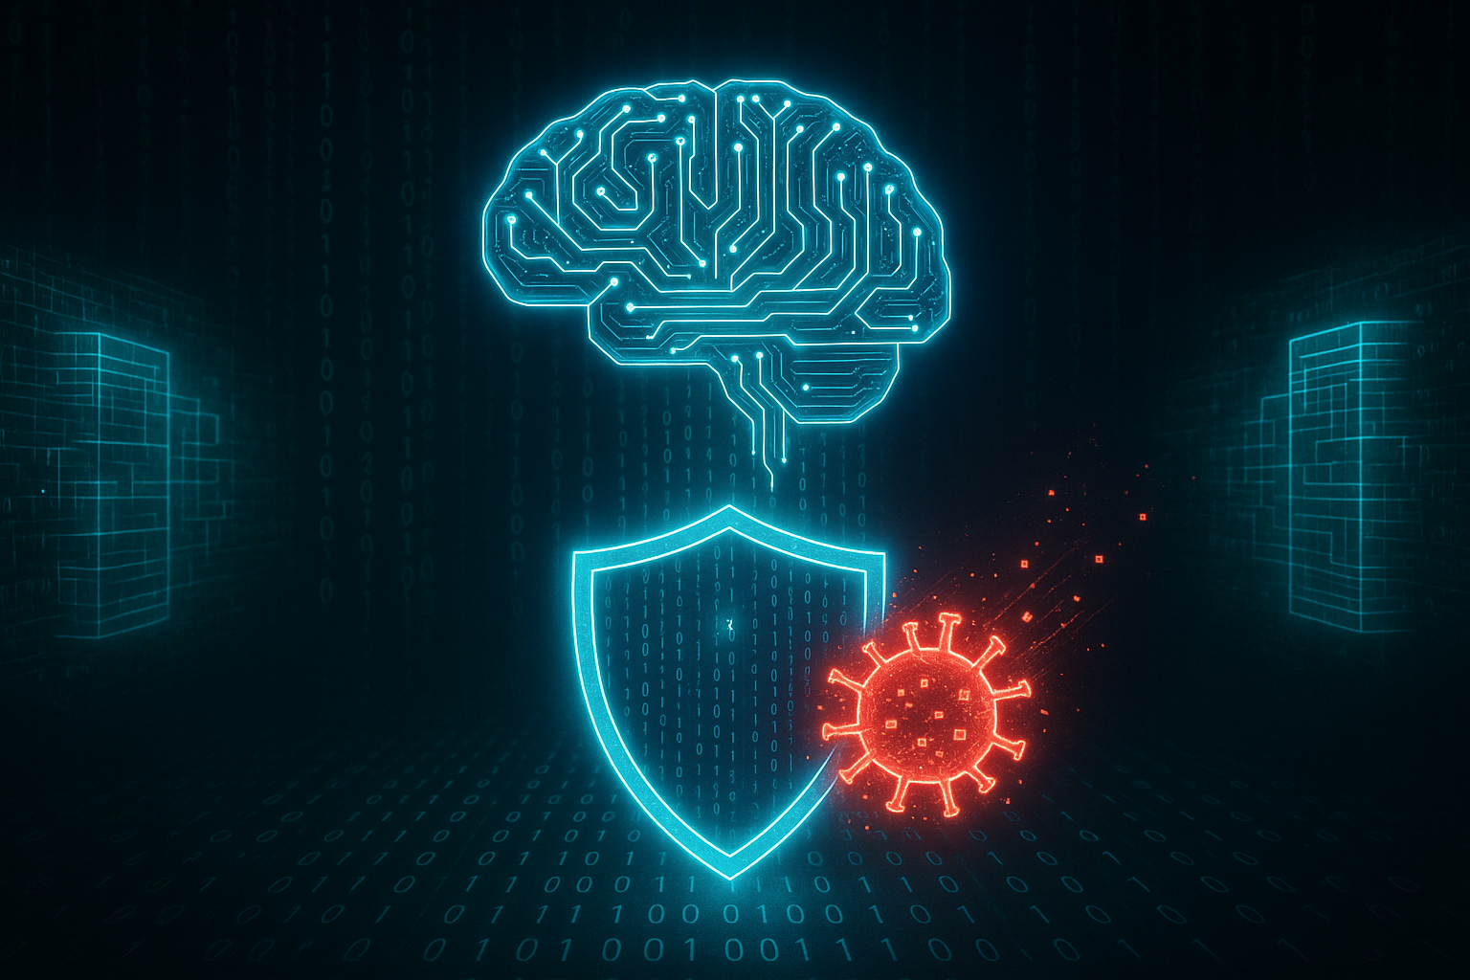

Cybersecurity strategies have traditionally relied on rule-based mechanisms such as firewalls, antivirus software, intrusion detection systems (IDS), and manual threat intelligence. However, with the rapid evolution of cyber threats—such as Advanced Persistent Threats (APTs), ransomware, phishing campaigns, and zero-day exploits—these traditional approaches are increasingly proving insufficient.

**REIMAGINING CYBERSECURITY: THE INTELLIGENT EVOLUTION OF DIGITAL DEFENSE**

**1. Pre-AI Era: Reactive Cybersecurity (Before 2000s)**

Before artificial intelligence (AI) became a prominent force in cybersecurity, defense strategies were largely reactive and rule-based. Traditional cybersecurity systems used **signature-based detection**, where known virus or malware patterns (signatures) were stored in databases. When a new file or process ran on a system, it was compared against this database. If the signature matched a known threat, it was blocked or flagged.

While effective against known threats, these systems were **ineffective against zero-day attacks** (previously unseen vulnerabilities) or polymorphic malware that could change its signature. This approach led to a constant “cat-and-mouse” game between attackers creating new variants and defenders updating their databases. There was **minimal automation**, and human intervention was needed for complex decisions or new threat patterns.

**2. The Emergence of AI Concepts in Security (Early 2000s)**

As computing power increased and cyber threats became more complex, researchers began experimenting with early AI techniques such as **heuristics** and **basic machine learning (ML)** for anomaly detection. Instead of matching specific patterns, heuristic-based systems attempted to **evaluate the behavior** of files and applications to identify potentially malicious activities.

Machine learning was introduced to cybersecurity in a **supervised learning** format—models were trained on labeled datasets of known good and bad behaviors. These models could **recognize patterns that deviate from normal behavior**, a key capability for detecting insider threats or zero-day attacks. However, this early use was limited by a lack of large-scale training data and relatively immature algorithms.

**3. Adoption of Machine Learning in Enterprise Cybersecurity (2010s)**

The 2010s marked a major turning point in the use of AI for cybersecurity. With the explosion of data generated by users, applications, and devices, it became clear that **manual monitoring was no longer feasible**. AI provided a scalable way to process and analyze this data in real time.

During this period, cybersecurity solutions began integrating ML models for:

* **Spam filtering** (e.g., Google’s use of AI to block phishing emails)
* **Intrusion Detection Systems (IDS)**
* **Endpoint protection** (e.g., Cylance using ML to detect malware without signatures)
* **Network traffic analysis**

Machine learning models were **trained on massive datasets**, making them significantly more effective at detecting subtle indicators of compromise (IOCs). AI-based tools could identify new threats by comparing behavior against a baseline, even if they had never seen the specific malware variant before.

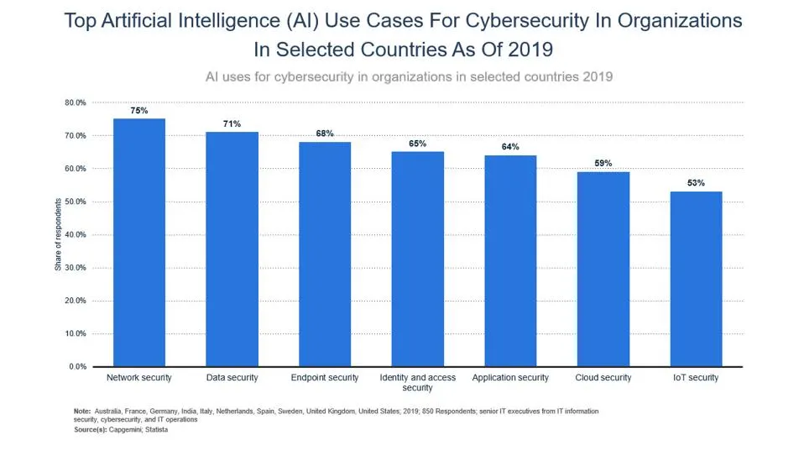

**4. Rise of Deep Learning and AI-Driven Platforms (Late 2010s – Early 2020s)**

The next leap came with the integration of **deep learning**, a subfield of AI that leverages neural networks capable of learning from vast, unstructured data sources such as images, emails, logs, and natural language.

Applications included:

* **Phishing detection** using natural language processing (NLP) to analyze the tone and content of emails.
* **User and Entity Behavior Analytics (UEBA)**: AI systems learned individual user behaviors and flagged anomalies.
* **Security Information and Event Management (SIEM)** platforms** integrated AI to correlate events across large, complex systems in real time.
* **Automated threat hunting**, where AI systems proactively searched for latent threats in networks without needing predefined signatures.

With companies adopting cloud services and remote work models, AI became essential for **scaling security operations** and managing **distributed environments**.

**5. AI-Enhanced Automation and Threat Intelligence (2020s–Present)**

In the current landscape, AI is integral to cybersecurity operations, contributing to:

* **Security Orchestration, Automation and Response (SOAR)**: AI enables automatic triage and response to incidents without manual intervention.
* **Threat Intelligence Platforms**: AI tools collect, process, and contextualize vast sources of threat data from the dark web, social media, and global attack patterns.
* **Zero Trust Architectures**: AI enforces adaptive access control by continuously monitoring users and devices.

Companies like **Darktrace**, **CrowdStrike**, and **SentinelOne** lead in AI-based solutions that combine ML, deep learning, and behavioral analytics for proactive defense.

**6. Challenges and Ethical Considerations**

Despite its promise, AI in cybersecurity also presents challenges:

* **False positives** from overly sensitive models can overload security teams.
* **Adversarial AI** techniques are emerging, where attackers attempt to deceive or manipulate AI systems.
* **Data privacy and bias** are concerns when training models on sensitive user data.

The cybersecurity arms race has evolved—**just as defenders use AI, attackers are starting to deploy AI to craft more evasive and adaptive threats**.

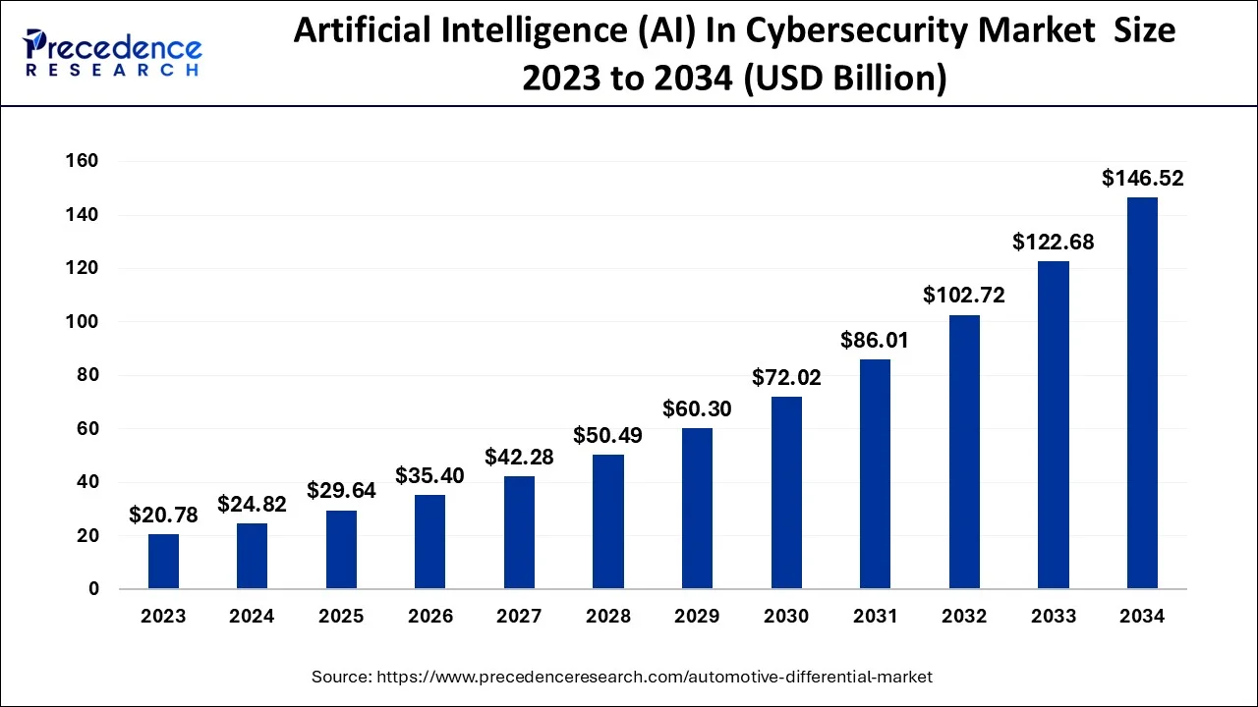

**7. The Future: Autonomous Cyber Defense**

The future of AI in cybersecurity lies in **fully autonomous systems** that can:

* **Detect, analyze, and respond** to threats within seconds.
* Use **AI-generated threat simulations** to continuously test systems.
* Collaborate through **federated learning** where models improve collectively without sharing raw data.

AI will continue to be both a shield and a sword in the digital world—requiring constant vigilance, innovation, and ethical oversight.

**AI-DRIVEN CYBERSECURITY APPLICATIONS**

**3.1 Threat Detection**

**How it works:**

AI enhances threat detection by identifying anomalies in network traffic and user behavior. Techniques like Isolation Forests and Autoencoders are employed to establish a baseline of normal activity. Deviations from this baseline can indicate potential threats.

**Example:** In the banking sector, AI models monitor user login times and transaction patterns. If a user who typically logs in during business hours suddenly accesses their account at an unusual time or initiates atypical transactions, the system flags this behavior for further investigation.

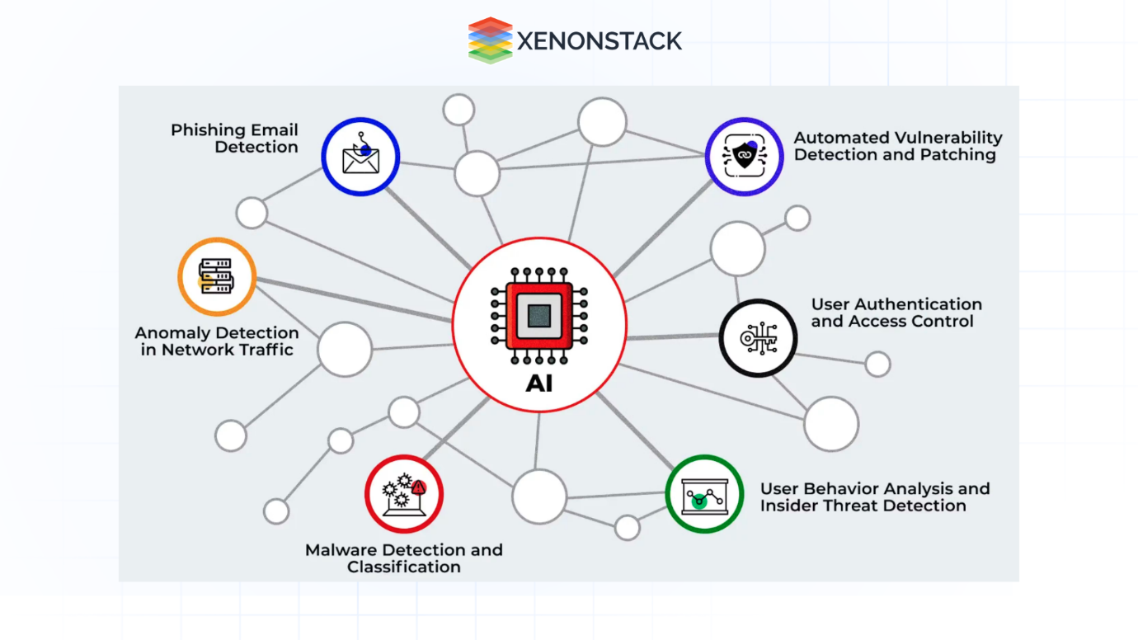

**3.2 Malware Classification**

**How it works:**

Traditional malware detection relies on signature-based methods, comparing code snippets to known malware databases. However, AI introduces advanced techniques:

* **Opcode Sequence Analysis:** By analyzing sequences of operational codes (opcodes) extracted from executable files, AI models can identify patterns indicative of malware.[ResearchGate](https://www.researchgate.net/publication/341574418_Malware-Detection_Method_with_a_Convolutional_Recurrent_Neural_Network_Using_Opcode_Sequences?utm_source=chatgpt.com)
* **Convolutional Neural Networks (CNNs):** CNNs can process binary patterns or opcode sequences, learning to distinguish between benign and malicious code.

**Example:** Antivirus software integrates CNNs trained on vast datasets of malware samples. This enables the detection of polymorphic malware, which alters its structure to evade traditional signature-based detection.

**3.3 Intrusion Detection Systems (IDS)**

**How it works:**

AI-powered IDS utilize supervised machine learning models trained on labeled datasets to detect unauthorized access or anomalies:

* **Random Forests:** An ensemble learning method that constructs multiple decision trees for classification tasks.
* **k-Nearest Neighbors (k-NN):** Classifies data points based on the majority class among its k-nearest neighbors.

**Example:** Smart grids employ AI-enhanced IDS to monitor real-time data flow. If the system detects patterns consistent with Distributed Denial of Service (DDoS) attacks, such as sudden surges in energy usage, it triggers alerts for immediate response.

**3.4 Automated Threat Response**

**How it works:**

AI facilitates automated responses to detected threats, minimizing response time:

* **Decision Trees:** Guide the AI system in executing predefined actions based on threat severity and confidence scores.
* **Robotic Process Automation (RPA):** Automates repetitive tasks, enabling swift mitigation measures without human intervention.

**Example:** Darktrace's AI system, Antigena, autonomously responds to threats by isolating affected devices and restricting user access upon detecting lateral movement within the network.

**3.5 Email Phishing Detection**

**How it works:**

AI combats phishing by analyzing various aspects of emails:

* **Natural Language Processing (NLP):** Examines email content, subject lines, and embedded URLs to identify suspicious patterns.
* **Image Recognition:** CNNs scan attachments and logos to detect visual deception tactics used in phishing attempts.

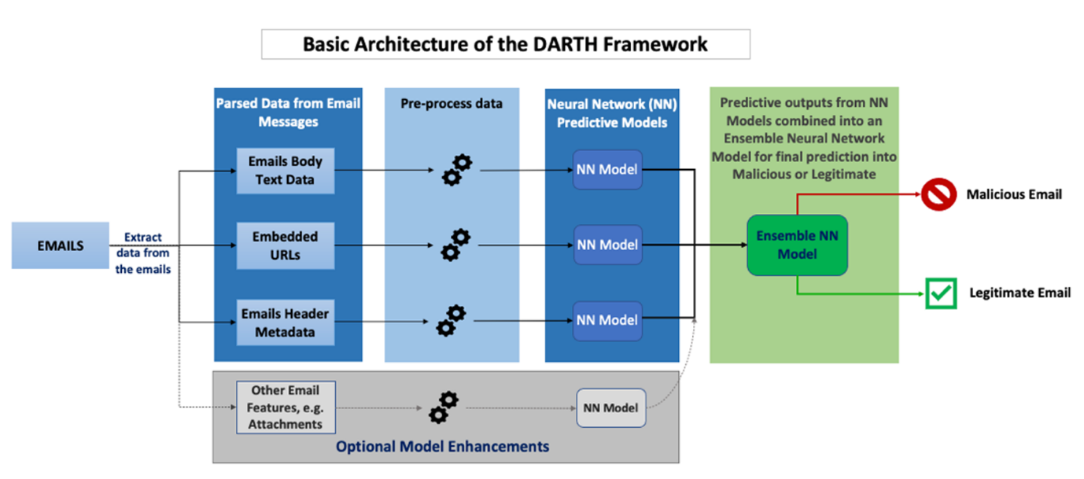

**Example:** AI-powered email gateways scrutinize incoming messages for anomalies, such as slightly altered domain names or suspicious links, effectively flagging potential phishing emails.

**3.6 User Behavior Analytics (UBA)**

**How it works:**

UBA leverages AI to monitor and analyze user activities:

* **Clustering Algorithms (e.g., K-Means):** Group similar behaviors to establish normal activity patterns.[LinkedIn](https://www.linkedin.com/pulse/behavioral-analytics-ai-mesh-insider-threat-auditing-andre-ciwte?utm_source=chatgpt.com)
* **Time Series Analysis with Long Short-Term Memory (LSTM):** Captures temporal dependencies in user behavior over time.

**Example:** In corporate environments, if an employee who typically accesses data during work hours suddenly initiates large data downloads at midnight, the system flags this as a potential insider threat.

**3.7 Fraud Detection in Finance**

**How it works:**

AI enhances fraud detection by identifying irregularities in financial transactions:

* **Supervised Learning:** Models are trained on labeled datasets to distinguish between legitimate and fraudulent transactions.
* **Graph Neural Networks (GNNs):** Analyze relationships between entities, uncovering hidden fraud rings by mapping complex transaction networks.

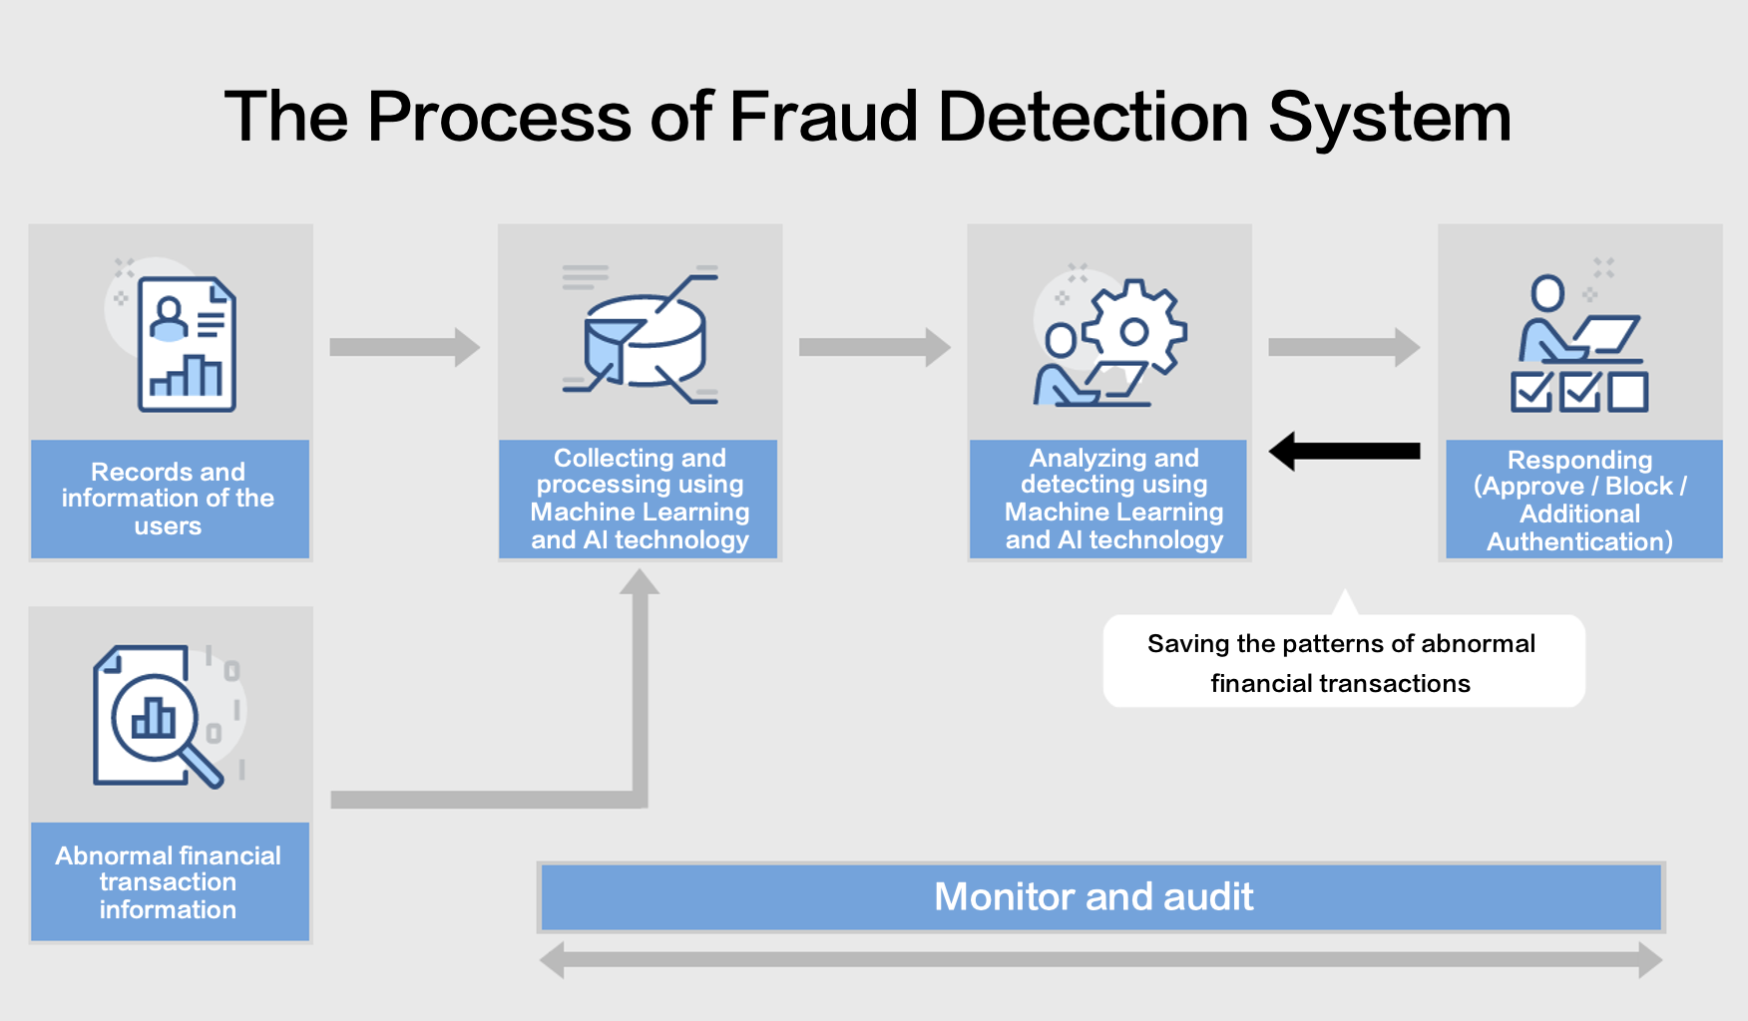

**Example:** Financial institutions employ AI to monitor credit card transactions. If a card is used in geographically distant locations within a short time frame, the system flags this as suspicious, aiding in the reduction of fraud by significant margins.

**LIMITATIONS AND CHALLENGES OF AI IN CYBERSECURITY**

**1. Adversarial AI**

**Overview:**Adversarial AI involves techniques where attackers craft inputs designed to deceive AI models. These inputs can cause AI systems to make incorrect predictions or classifications, potentially leading to security breaches.

**Example:**An attacker subtly alters an image of a stop sign so that an AI-powered autonomous vehicle misclassifies it as a speed limit sign, leading to dangerous consequences.

**2. Data Dependency**

**Overview:**AI models require vast amounts of high-quality, diverse, and unbiased data to function effectively. In cybersecurity, obtaining such datasets can be challenging due to privacy concerns and the evolving nature of threats.

**Challenges:**

* Data Scarcity: Limited availability of labeled cybersecurity data hampers model training.
* Bias: Biased datasets can lead to models that perform poorly across different **scenarios.**

**3. Explainability**

**Overview:**Many AI models, especially deep learning networks, operate as "black boxes," making it difficult to understand their decision-making processes. This lack of transparency poses challenges in cybersecurity, where understanding the rationale behind alerts is crucial.

**Implications:**

* Trust Issues: Security professionals may hesitate to act on AI-generated alerts without clear explanations.
* Compliance: Regulatory standards often require transparency in decision-making processes.

**4. Job Displacement**

**Overview:**The integration of AI in cybersecurity automates many tasks traditionally performed by humans, leading to concerns about job displacement.

**Current Scenario:**Companies like CrowdStrike have announced layoffs, attributing them to efficiencies gained through AI integration.

**HUMAN-AI TEAMING IN CYBER DEFENSE**

In the rapidly evolving landscape of cybersecurity, the integration of Artificial Intelligence (AI) with human expertise—commonly referred to as *human-AI teaming*—has become increasingly vital. AI systems bring unparalleled advantages in terms of speed and scale; they can analyze millions of logs, detect anomalies in real time, and identify potential threats across vast networks far more efficiently than human analysts alone. This capability is especially crucial when dealing with large-scale attacks such as ransomware, data breaches, or distributed denial-of-service (DDoS) attacks, where the volume of data can overwhelm manual monitoring systems.

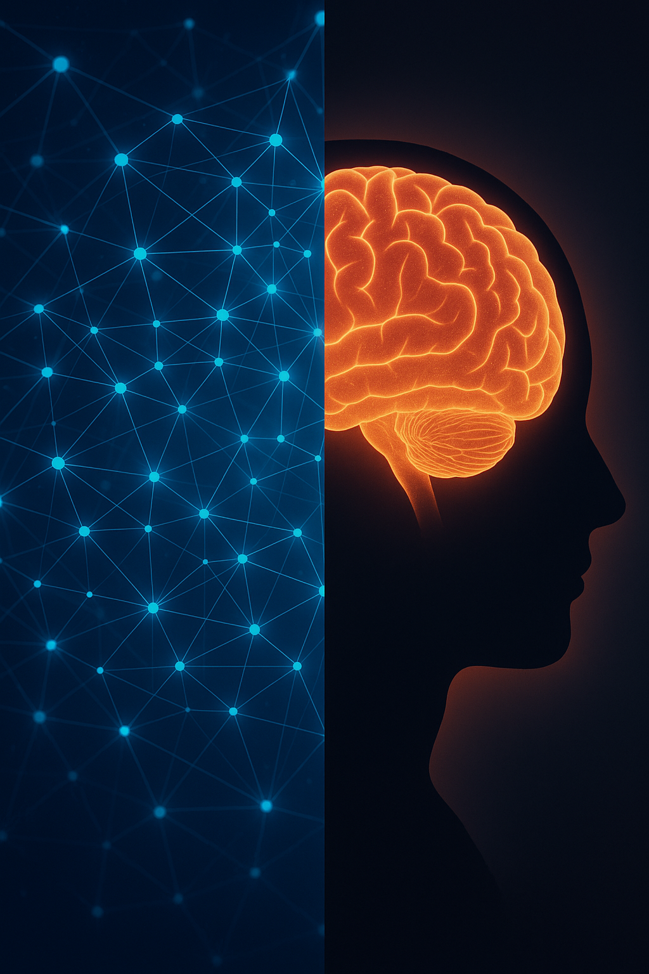

However, while AI excels at identifying patterns and flagging suspicious behavior, it often lacks the contextual awareness and critical reasoning skills required to accurately interpret complex threats. This is where human analysts play a critical role. Cybersecurity professionals bring to the table a deep understanding of organizational context, business operations, and legal or ethical considerations that AI systems do not inherently possess. For example, an AI may flag an unusual login from a foreign country as malicious, but a human analyst might recognize it as a legitimate access due to a business trip.

Moreover, human involvement is essential in reducing false positives and in making judgment calls on sensitive actions—such as whether to isolate a device, block a user, or shut down parts of a system. These decisions can have significant operational and financial consequences and are better evaluated by human experts. In addition, humans are required for strategic planning, policy enforcement, and communication with stakeholders during or after cyber incidents.

A practical example of human-AI collaboration can be seen in advanced security operations centers (SOCs), where AI tools continuously monitor network behavior and generate alerts, while human analysts validate these alerts, investigate root causes, and initiate appropriate responses. Platforms like IBM’s QRadar or Darktrace’s Enterprise Immune System demonstrate how this synergy boosts overall threat detection and incident response capabilities.

Ultimately, human-AI teaming not only enhances operational efficiency but also builds trust in AI systems. As regulatory pressures increase around the explainability and accountability of AI decisions, human oversight ensures that cybersecurity measures remain transparent, ethical, and aligned with organizational values. By working together, AI and human analysts create a resilient defense posture that adapts quickly to new threats while maintaining the judgment and nuance required for effective cyber governance.

**RESEARCH GAPS IN AI-DRIVEN CYBERSECURITY**

**1. Adversarial AI Vulnerability**

Despite rapid advancements in AI-powered detection systems, they remain highly susceptible to adversarial attacks. These attacks involve crafting input data in such a way that it appears benign to AI systems but actually contains malicious intent. For example, attackers can modify malware signatures or network packet sequences in imperceptible ways to bypass detection. This vulnerability poses a serious risk, especially for mission-critical environments like finance and national defense, where false negatives can have severe consequences. Current research lacks robust, generalizable solutions to make AI systems resilient against these sophisticated adversarial manipulations.

**2. Lack of Explainability in AI Models**

Deep learning models, particularly those based on neural networks, are often considered "black boxes" because their decision-making processes are difficult to interpret. In cybersecurity, explainability is crucial—not just for understanding why a system flagged a particular threat, but also for satisfying regulatory compliance and justifying automated actions. For instance, in sectors governed by GDPR or HIPAA, organizations must explain why certain alerts led to blocking access or isolating users. However, many AI-driven tools cannot provide human-readable justifications, creating a trust gap between the system and its human operators. Research into interpretable AI for cybersecurity is still in its early stages.

**3. Data Limitations and Model Bias**

AI models in cybersecurity heavily rely on large volumes of labeled data for training. Unfortunately, high-quality, real-world cybersecurity datasets are difficult to obtain due to privacy concerns, proprietary restrictions, and the constantly evolving nature of cyber threats. As a result, many models are trained on synthetic datasets like KDD’99 or NSL-KDD, which no longer represent modern attack patterns. Moreover, biased or imbalanced datasets can cause models to overfit or underperform in detecting rare but critical threats. The gap in availability of diverse, real-time datasets limits the development of adaptive and generalized AI solutions.

**4. Underexplored Human-AI Teaming**

While the concept of combining human expertise with AI’s speed and pattern recognition is gaining attention, few practical implementations exist that allow real-time, collaborative decision-making. Most systems either automate tasks without human intervention or rely entirely on manual inputs. Effective human-AI teaming should involve AI handling routine tasks and surfacing complex issues to analysts, who then provide contextual judgment. However, there’s a lack of research on how to structure this interaction, balance control, and build trust between humans and machines in dynamic cybersecurity environments. This underexplored area represents a significant gap in designing hybrid defense systems.

**5. Scalability and Integration Challenges**

AI solutions that perform well in controlled environments often struggle when deployed across enterprise-scale networks. Scalability issues arise due to the diversity of network architectures, legacy systems, and the heterogeneity of threat vectors. Integrating AI tools into existing security information and event management (SIEM) systems or with older infrastructure can be complex, resource-intensive, and sometimes incompatible. Additionally, performance can degrade when models are exposed to noisy, high-volume data or real-time processing constraints. More research is needed into scalable, modular AI architectures that can adapt to various operational settings without loss of effectiveness.

**6. Ethical and Regulatory Challenges**

The rapid deployment of AI in cybersecurity brings with it significant ethical, legal, and regulatory concerns. For instance, should an AI system be allowed to autonomously quarantine devices or block users without human oversight? Who is accountable if an AI-driven security response disrupts operations or violates user privacy? Currently, there is limited scholarly and industrial research into the governance of AI in cybersecurity, especially in high-risk domains like government surveillance, law enforcement, and critical infrastructure. Ensuring responsible AI use, developing transparent auditing mechanisms, and aligning with legal frameworks remain pressing challenges that require interdisciplinary collaboration.

**FUTURE DIRECTIONS AND OPPORTUNITIES IN AI-DRIVEN CYBERSECURITY**

**1. Advanced Threat Intelligence and Proactive Defense**

AI is expected to evolve from passive threat detection to active threat anticipation. Future systems will be capable of integrating threat intelligence feeds from multiple global sources—dark web monitoring, honeypots, network logs, and third-party databases—to proactively predict attack vectors before they materialize. These predictive systems will utilize techniques such as *graph neural networks (GNNs)* to understand relationships between entities and behaviors, identifying suspicious patterns that may signal upcoming threats.

**Opportunity:** Real-time global collaboration between AI agents to neutralize threats preemptively, particularly beneficial in sectors like critical infrastructure and finance.

**2. Federated Learning and Privacy-Preserving AI**

Data privacy laws (e.g., GDPR, HIPAA) limit the availability of shared cybersecurity datasets. **Federated learning** offers a future-forward solution, enabling multiple organizations to collaboratively train AI models without transferring sensitive data. Each node trains its local model and only shares updates (gradients) with a central server, preserving data confidentiality.

**Opportunity:** Building robust AI models across industries (e.g., healthcare, banking, government) without violating privacy laws, and enhancing overall ecosystem security.

**3. Explainable and Interpretable AI (XAI)**

Future AI tools will prioritize transparency and accountability through **Explainable AI (XAI)**. Techniques such as LIME (Local Interpretable Model-agnostic Explanations) or SHAP (SHapley Additive exPlanations) will allow security professionals to understand why an AI flagged a specific event, increasing user trust and simplifying compliance with auditing regulations.

**Opportunity:** Enhanced trust in AI-driven decisions across regulated sectors; improved collaboration between AI systems and human analysts during critical incidents.

**4. Autonomous Cyber Defense and Self-Healing Systems**

The future will witness a shift towards **autonomous cyber response**, where AI systems take near-instantaneous action upon detecting anomalies. Such systems will not only isolate threats but also implement recovery protocols—restoring compromised systems and reconfiguring defenses without human intervention. Technologies like **AI-driven SOAR (Security Orchestration, Automation, and Response)** platforms will become mainstream.

**Opportunity:** Millisecond-level response times that minimize damage in the event of fast-spreading malware, ransomware, or DDoS attacks.

**5. Human-AI Symbiosis in Cybersecurity Operations**

Instead of replacing human professionals, AI will increasingly serve as a co-pilot—handling routine and repetitive tasks while humans focus on strategy, investigation, and decision-making. For instance, AI will pre-process massive logs and surface high-priority incidents, allowing security analysts to act more efficiently.

**Opportunity:** Creation of hybrid security teams where AI enhances human performance, reduces burnout, and improves incident resolution rates.

**6. Cross-Platform and IoT Security Integration**

As the number of IoT and edge devices explodes, AI will play a vital role in monitoring and protecting these often unguarded endpoints. AI models will be embedded at the edge to detect anomalies in real-time, without requiring constant cloud connectivity. In cloud environments, AI will monitor user behavior, API calls, and access logs to detect cloud-specific threats like privilege escalation or credential theft.

**Opportunity:** Comprehensive, AI-driven defense across cloud, mobile, IoT, and edge environments—forming a unified security fabric.

**7. Quantum-Aware Cybersecurity**

With the advancement of **quantum computing**, traditional encryption methods may become obsolete. AI will help identify cryptographic vulnerabilities in post-quantum transition phases, suggesting remediation strategies and testing the resilience of quantum-resistant algorithms.

**Opportunity:** Use of AI to accelerate the adoption and monitoring of post-quantum cryptography, safeguarding national and enterprise-level systems.

**8. AI-Powered Deception Technologies**

AI will be used to power **cyber deception technologies**—systems that deploy decoys and traps (honeypots, honeytokens) across networks to lure attackers. These AI-powered systems can dynamically reconfigure themselves based on the attacker's behavior, collecting intelligence and delaying breaches.

**Opportunity:** More intelligent, adaptive deception strategies that confuse attackers and provide valuable threat intelligence without compromising real assets.

**9. Ethical AI Governance and Policy Development**

As AI becomes more powerful, its use must be ethically grounded. Future directions include building frameworks for responsible AI use, including accountability for automated decisions, ethical data sourcing, and minimizing bias. AI audit trails and policy-based access controls will also become standard.

**Opportunity:** Development of internationally accepted norms and laws around AI use in cybersecurity, balancing innovation with civil rights.

**10. Cybersecurity-as-a-Service (CaaS) with AI**

Small and medium-sized businesses (SMBs) often lack resources for full-time security teams. AI-driven **Cybersecurity-as-a-Service (CaaS)** platforms will democratize access to advanced threat detection and response capabilities via subscription-based cloud platforms.

**Opportunity:** Wider accessibility of intelligent cybersecurity solutions for SMBs, NGOs, and schools—narrowing the protection gap between large and small organizations.

**CONCLUSION**

In conclusion, Artificial Intelligence is poised to revolutionize the field of cybersecurity, offering powerful solutions to address the ever-evolving landscape of cyber threats. From detecting sophisticated malware to automating threat response and predicting emerging vulnerabilities, AI has already begun to reshape how organizations defend against cyberattacks. The synergy between machine learning models, big data, and real-time processing creates a more agile, efficient, and proactive defense system compared to traditional approaches.

The report highlights the significant advancements AI has made in areas such as threat detection, malware classification, and intrusion detection, making it an essential tool for modern cybersecurity infrastructures. Technologies such as Anomaly Detection, Deep Learning, and Natural Language Processing are improving the accuracy and efficiency of security operations, while AI-driven automation is enabling faster and more reliable responses to incidents, thereby minimizing human error and reducing the time to mitigate damage. However, the deployment of AI in cybersecurity also brings a set of challenges that must be addressed for broader adoption. Adversarial attacks, the lack of explainability in AI models, data limitations, and bias remain critical issues that need focused research and development. Moreover, the integration of AI with existing systems, especially in legacy environments, and the need for cross-platform security across IoT, cloud, and edge devices, represent significant hurdles. The ethical and regulatory challenges surrounding AI's use in cybersecurity are also an area that will require close attention, especially as AI begins to make decisions autonomously, impacting privacy, accountability, and fairness.

As Human-AI teaming becomes more advanced, AI will work alongside human analysts to improve decision-making, offering both speed and nuanced judgment in cyber defense strategies. Furthermore, AI-powered deception technologies, quantum-resilient systems, and Cybersecurity-as-a-Service models will open up new opportunities, making advanced

As we look ahead, the convergence of AI, machine learning, and cybersecurity will continue to define the next phase of digital security. With continuous innovation, collaboration, and responsible deployment, AI-driven cybersecurity systems will be crucial in defending the digital world against ever-growing threats, providing organizations with the tools they need to protect their most valuable assets.

**REFRENCES**

**[1] O. S. Albahri and A. H. AlAmoodi, "Cybersecurity and Artificial Intelligence Applications: A Bibliometric Analysis Based on Scopus Database," in *Mesopotamian Journal of Cybersecurity*, vol. 2023, pp. 158–169, 2023.**

**[2] J. Li, "Cyber Security Meets Artificial Intelligence: A Survey," in *Frontiers of Information Technology & Electronic Engineering*, vol. 19, no. 12, pp. 1462–1474, 2018.**

**[3] V. Božić, "Artificial Intelligence: The New Frontier in Cybersecurity," in *ResearchGate*, Research Proposal, Sep. 2024. DOI: 10.13140/RG.2.2.35234.03529.**

**[4] I. H. Sarker, H. Janicke, N. Mohammad, P. Watters, and S. Nepal, "AI Potentiality and Awareness: A Position Paper from the Perspective of Human-AI Teaming in Cybersecurity," *arXiv preprint*, arXiv:2310.12162v1, Sep. 2023.**

**[5] M. F. Ansari, B. Dash, P. Sharma, and N. Yathiraju, "The Impact and Limitations of Artificial Intelligence in Cybersecurity: A Literature Review," in *International Journal of Advanced Research in Computer and Communication Engineering*, vol. 11, no. 9, pp. 81–85, Sep. 2022. DOI: 10.17148/IJARCCE.2022.11912.**